**Supporting information**

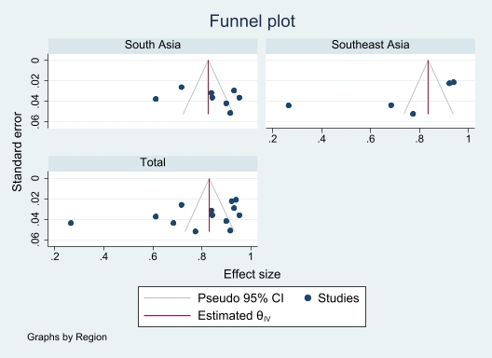

**S1. Funnel plot of the prevalence of good knowledge towards COVID-19 epidemic in South Asia and Southeast Asia.**

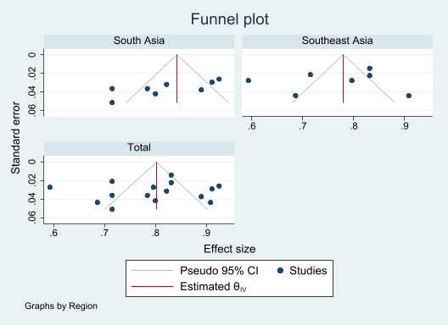

**S2. Funnel plot of the prevalence of positive attitude towards COVID-19 epidemic in South Asia and Southeast Asia.**

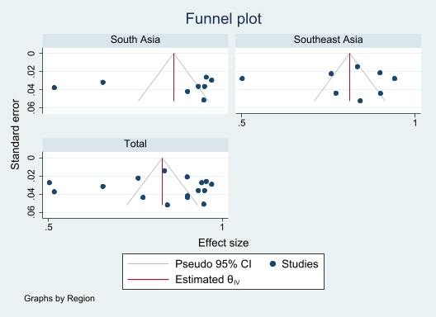

**S3. Funnel plot of the prevalence of frequent practice towards COVID-19 epidemic in South Asia and Southeast Asia.**